

COOPERATIVE

**January- March Edition**

**A Publication of the Lagos State Cooperative Federation**

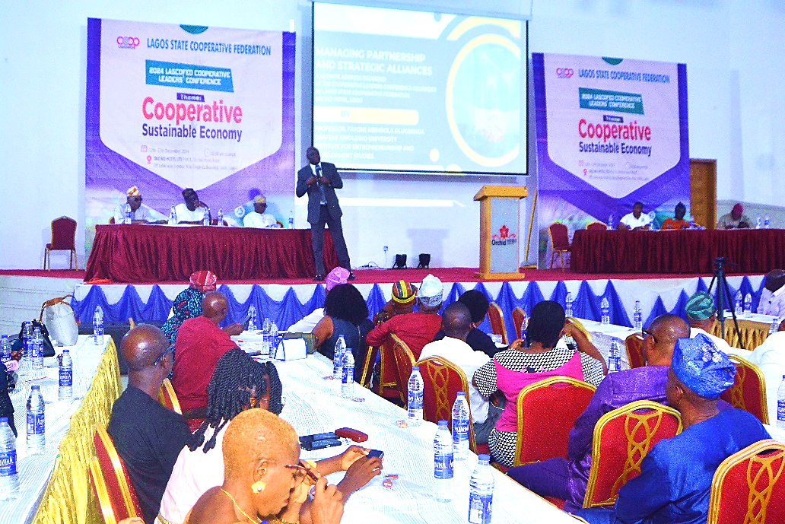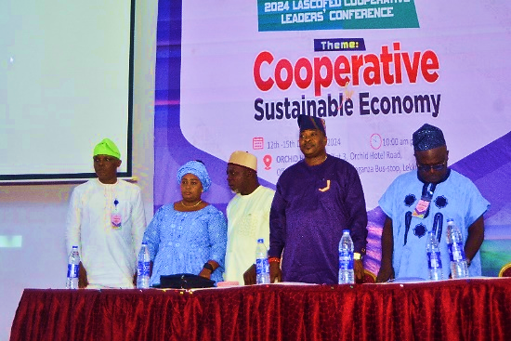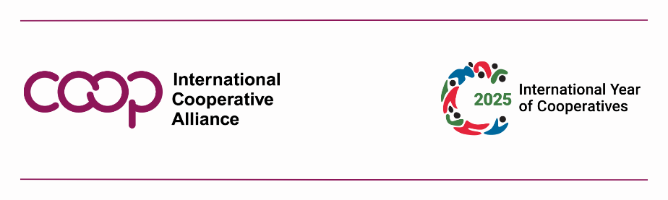

NEWSLETTER

A Quarterly Publication of Lagos State Cooperative Federation

03.25.2025/ TUESDAY

www.Lascofed.coop

President in Council

Barr. Oladipo Shobule

President LASCOFED

their products and services, creating opportunities for patronage and networking and cooperation amongst Cooperatives.

**Networking and Social Activities**

A highlight of the conference was the Dinner and Coop Night, held on December 14, where attendees bonded over entertainment.

**Emphasis on Sustainability**

The conference introduced sustainability initiatives, including participant tags equipped with QR codes for digital access to the program brochure, minimizing paper usage. LASCOFED plans to phase out printed materials entirely by 2025.

**Key Partnerships and Announcements**

**LASCOFED/FMCG Partnership**

A key focus was the innovative partnership between LASCOFED and Fast Moving Consumer Goods (FMCG) companies. By eliminating inefficiencies in the traditional retail supply chain, this collaboration enables cooperative members to access essential goods at reduced costs while offering FMCG companies a direct distribution channel.

* A second technical session, facilitated by a professor of entrepreneurship, focused on *“Managing Partnerships and Strategic Alliances,”* equipping participants with strategies for building sustainable relationships.

**Syndicate Group Discussions**  
Participants explored practical solutions to pressing issues within Lagos State Cooperative Movement, including:

1. Development strategies for the Cooperative Resort Centre in Mojoda.
2. Leadership and conflict management within cooperatives.
3. Enhancing the LASCOFED/FMCG partnership to streamline the supply chain.
4. Growth strategies for LASCOFED Travels and Tours Ltd.

**Health Awareness and Exhibitions**  
Health remained a priority, with early morning medical tests for blood pressure and fasting blood sugar conducted daily. Product exhibition paved way for cooperative societies to showcase

Deputy Director of Cooperative in the ministry Mr. Kazeem Omotayo. Barr. Shobule emphasized the importance of the conference as a capstone for LASCOFED’s annual training programs and a testament to the significant contributions of cooperatives to Lagos economy.

Acknowledging the logistical challenges posed by the large attendance, Barr. Shobule reiterated LASCOFED’s commitment to embarking on the proposed Cooperative Resort Centre project located at Mojoda, Epe Lagos State. The project, envisioned as a hub for cooperative activities, aims to reduce reliance on commercial hotel accommodations for events of such magnitude.

**Conference Highlights**

The four-day event featured a variety of sessions and activities designed to engage participants in meaningful discussions, foster collaboration, and promote well-being.

**Plenary and Technical Sessions**

* *“Mitigating Potential Risks Using Technology”* examined the challenges and opportunities of technology adoption in cooperative operations

**LAGOS, NIGERIA** –December 12 to 15, 2024

Cooperative leaders, stakeholders, and policymakers converged at the Orchid Hotel in Lekki, Lagos State, for the much-anticipated LASCOFED Cooperative Leaders' Conference. The conference theme, *“Cooperative for Sustainable Economy,”* served as a rallying point for discussions on advancing cooperative administration and economic development in Lagos State for the year 2024.

The annual event, organized by the Lagos State Cooperative Federation (LASCOFED), provided a platform for participants to exchange ideas, address emerging issues in cooperative management, and strengthen ties within the cooperative community.

LASCOFED President, **Barr. Oladipo Shobule**, in his opening address, warmly welcomed participants and expressed gratitude for their dedication throughout the year. Hon. **Folashade Ambrose Mebedem**, Commissioner for Commerce, Cooperatives, Trade, and Investment, was a distinguished guest at the event honorably represented by the

leadership, emphasizing the need for generational inclusivity in sustaining the movement.

Expressing gratitude, he acknowledged the support of corporate sponsors, including **Leadway Assurance**, **Cooperative Mortgage Bank**, **CWG Plc.**, **FAADAAKAA Group** and **Mouka Foam**, as well as the dedication of LASCOFED staff and volunteers. He concluded with warm wishes for the festive season and a call for active engagement during the International Year of Cooperatives in 2025, as declared by the United Nations.

As participants departed the conference, they left with actionable strategies and a renewed commitment to fostering a sustainable economy through cooperative principles. The LASCOFED Cooperative Leaders' Conference remains a vital forum for shaping the future of cooperatives in Lagos State and beyond.

This initiative underscores LASCOFED’s commitment to empowering members economically and fostering growth within the cooperative movement.

**Cooperative Resort Centre, Mojoda**

The development of the Cooperative Resort Centre, initiated in 2008, was revisited as a priority project. Cooperative societies were invited to invest in the project as shareholders to promote collective responsibility and shared benefits. This project reflects LASCOFED’s vision of creating a self-sustaining hub for cooperative education, training, and events.

**Calls to Action and Appreciation**

Barr. Shobule appealed to Hon. Ambrose Mebedem for assistance in ensuring that cooperatives are adequately captured in Lagos State’s economic data, highlighting the sector's contributions to the economy

. He also called for greater youth participation in cooperative

**LASCOFED Cooperative Leaders' Conference 2024: Paving the Path for a Sustainable Economy**

**The Medicals Cooperative Multipurpose Society Holds AGM**The AGM witnessed a change of baton in the leadership of the society. In what can be considered as seamless transition, Mrs. Olubanke Bodede emerged as the President of the society.

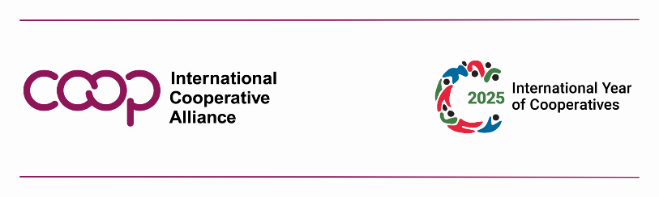

**MRS. OLUBANKE BODEDE**

**President The Medicals CMS**

neighboring communities to their society’s developed estate. The cooperative also invests in members’ education by sponsoring training and workshops to enhance their skills and knowledge in Leadership, cooperative management and in preparation for retirement.

The Cooperative highlighted delays in remittances from members’ employers, as challenge that affected timeline of loan disbursement timelines. Financial constraints and limited member interest in certain investment opportunities, such as estate purchases, also pose obstacles to growth.

repayments, reinforcing the strength of collective effort. Additionally, The Medicals processed over 140 loan applications monthly, with interest rates tailored to members’ needs. Welfare initiatives, including access to insurance, solar appliances, and electronics, further demonstrated the cooperative's dedication to its members’ well-being.

Beyond immediate financial benefits, The Medicals Cooperative has prioritized investments and asset development to secure long-term growth. The society holds shares in companies such as Nestle and Cadbury and operates ventures like a bread factory and ferry services. It has also acquired land in Badagry and developed an estate in Ikorodu, although mobilizing member interest in property investments remains a challenge.

While primarily workplace-centered, work-based cooperatives also contribute to broader community development. The Medicals has provided scholarships for members’ children and supported infrastructure projects like water supply for

Annual General Meeting (AGM) in cooperatives is characterized by rendition of account of stewardship and election of executives. The 2024 Annual General Meeting (AGM) of The Medicals (Lagos Island) Cooperative Multipurpose Society Limited held recently its AGM, showcasing the successes and challenges faced by the cooperative, highlighting the importance of cooperative for economic empowerment.

The Medicals Cooperative, consist of individuals in the medical profession and working under the same employer by a shared profession or workplace. These cooperative focuses on improving members' financial stability and productivity by pooling resources and providing access to credit. The Medicals, with a membership of 2,900, exemplifies the potentials of cooperatives for self-help through mutual help. Despite economic difficulties, the cooperative reported a net surplus of ₦93.96 million in 2023 and distributed ₦60.62 million in dividends to its members.

This achievement reflects the commitment of members to savings and timely loan

Despite these challenges, the potential for cooperative societies to drive sustainable development is enormous. By pooling resources, cooperatives provide access to credit, reduce individual risks, and support job creation. Addressing leadership deficiencies through training, improving access to funding, and establishing comprehensive cooperative databases could further enhance their impact.

The AGM witnessed a change of baton in the leadership of the society. In what can be considered as seamless transition, Mrs. Olubanke Bodede emerged as the President of the society. Thanks to well-structured tradition and succession plan instituted by the founders of the society and upheld by the elders and members.

In her closing remarks, the outgone President Mrs. Oshodi-Bakare M.O. emphasized the importance of collective action and stakeholder support in overcoming challenges and achieving meaningful progress.

**Director General of International Cooperative Alliance (ICA) Jeroen Douglas, Charges Cooperators across the World.**

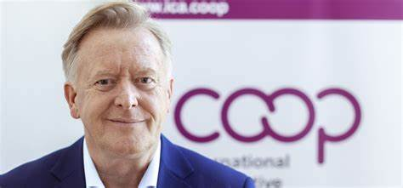

a commitment plan to accelerate SDGs and enhance the share of cooperatives and mutuals in the global economy.

This summit presents a unique opportunity to showcase the transformative power of the cooperative movement on a global stage. Let us use this platform to amplify our voices, forge new partnerships, and solidify our commitment to building a better world.

From all of us at ICA, I wish you a prosperous, healthy, and cooperative New Year!  
Let us step forward together, united in our mission to build a better world.

Onwards, together!  
  
**Jeroen Douglas**

**Director General of the ICA**

**JEROEN DOUGLAS**

Esteemed cooperators, colleagues, and friends around the world, as we embark on a New Year, a year designated by the United Nations as the International Year of Cooperatives, let's raise a glass to the unwavering spirit of the global cooperative movement. This year holds a special significance, marking again – let’s remember 2012 was the first UN International Year of Cooperatives! - a **global recognition of cooperatives' immense contributions towards a more just and equitable world**. The slogan of the year ‘Cooperatives build a better world’ rightly reflects this and captures the heart of our movement’s enduring mission.

The past year has presented its share of local and global challenges. We have witnessed economic downturns, social unrest, and environmental crises. Yet, through it all, **the cooperative spirit has remained steadfast, a beacon of hope** in a world that prioritizes profit over people and individualism over the general interest.

Our movement, like a vibrant tapestry woven from countless threads of cooperation, represents **a global network of communities, businesses, and shared dreams**. Each cooperative, from the smallest local credit union to the largest agricultural cooperative, plays a vital role in this intricate and colorful fabric. Together, we are a force for good. Over the past 130 years, the ICA has been at the forefront of the global cooperative movement, guiding

* Cooperation and solidarity are the cornerstones of our interactions.
* Democracy and participation are central to all our activities.
* Sustainability is integrated into all aspects of our operations

**Let us not be afraid to challenge the status quo, to advocate for change, and to build a better future for all.** Let us, like the wise and courageous members from all our countries, work together to create a world where cooperation truly shines as a beacon of hope.  
   
As we look ahead to the future, the culmination of the International Year of Cooperatives will be marked by the 2nd World Summit of Social Development in Qatar, in November 2025. We hope to deliver with our top Cooperative and Mutual Leaders through CM50 - our Charter of a Cooperative Future and - through our key partners

must further evolve and grow towards a larger share in the global economy. **We must embrace innovation, adapt to changing circumstances, and continue to champion the values that define us**: equity, self-help, social responsibility, and solidarity.  
   
We must continue to innovate and find new ways to address our communities' challenges.

We as cooperatives must explore new business models, embrace digital technologies, and invest in renewable energy. The recent rise of digital cooperatives, platform cooperatives, and social enterprises showcases the innovative spirit within our movement.

We must also ensure that our movement remains inclusive and accessible to all.   
Let us strive for a global cooperative movement—where all members thrive. Let us build a movement where:

* Economic growth is driven by social and environmental responsibility.

and supporting cooperatives worldwide. We have witnessed firsthand the **transformative power of cooperation, empowering communities, fostering economic growth, and promoting social inclusion**.

Worldwide, we have come together to address challenges  
like housing affordability and environmental sustainability, and so too have cooperatives tackled pressing global issues. Cooperatives have provided access to essential goods and services including health care, supported local economies, and empowered individuals to take control of their own destinies. You have played a **pivotal role in advancing the Sustainable Development Goals (SDGs)**, demonstrating that people-centered businesses can drive positive social and environmental change.  
We have also witnessed the power of collective action. As cooperatives united, we have advocated for **policies that support sustainable development, social justice, and economic democracy**.

But our work is far from over. The cooperative movement

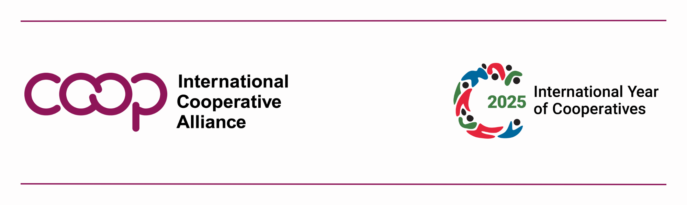

**Youth Inclusion: A Cornerstone for Cooperative Sustainability and Equity**

In an era where global economic systems often prioritize profit over people, cooperatives stand out as institutions committed to inclusivity, fairness, and sustainability

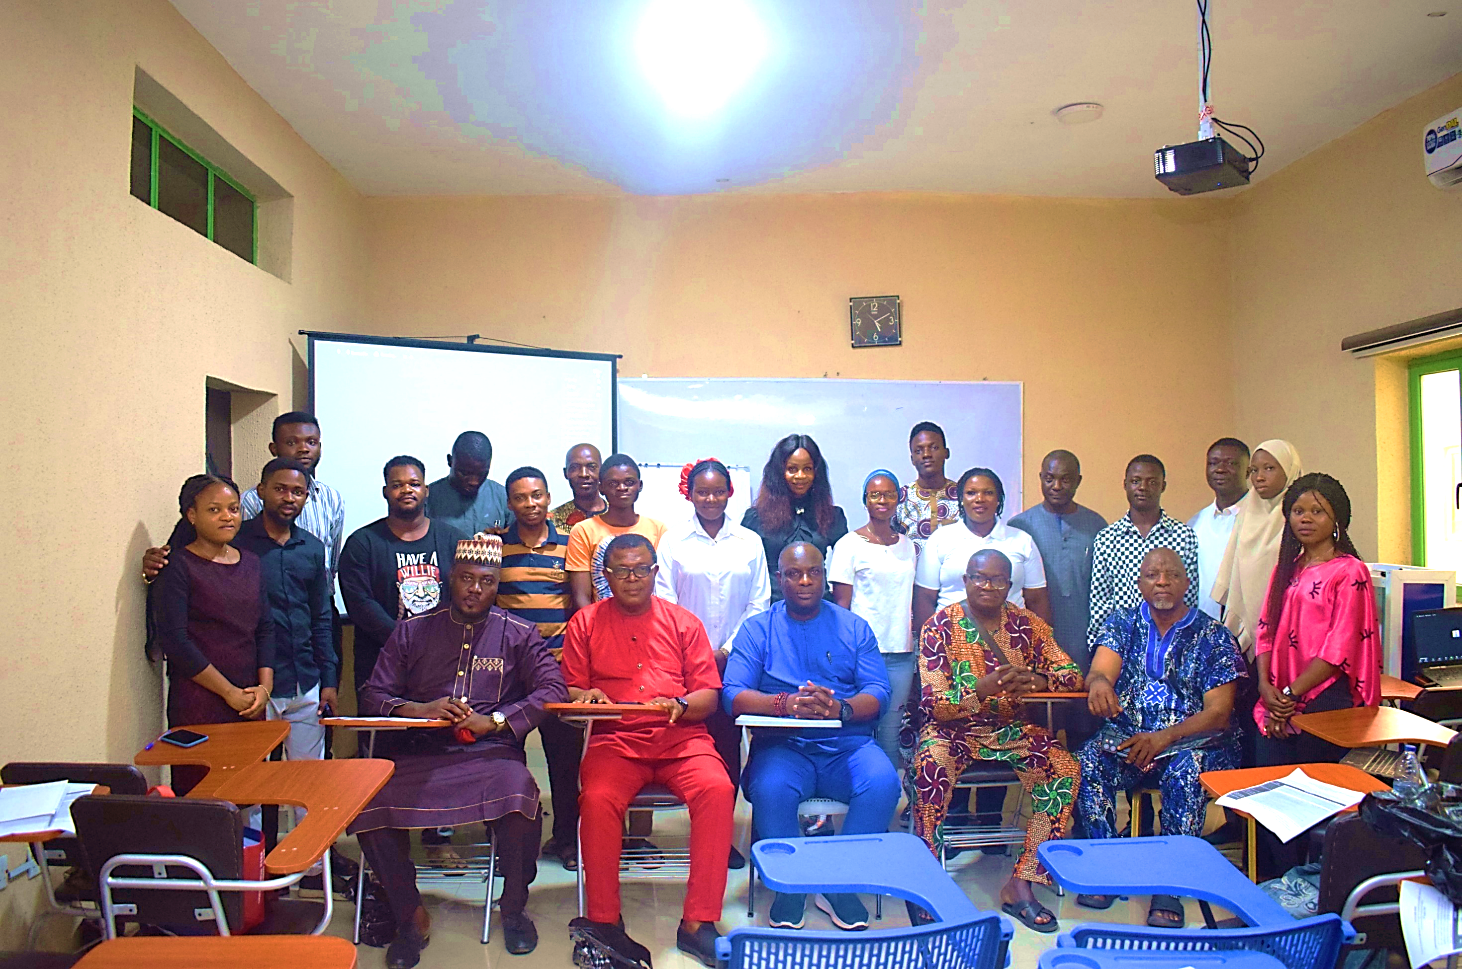

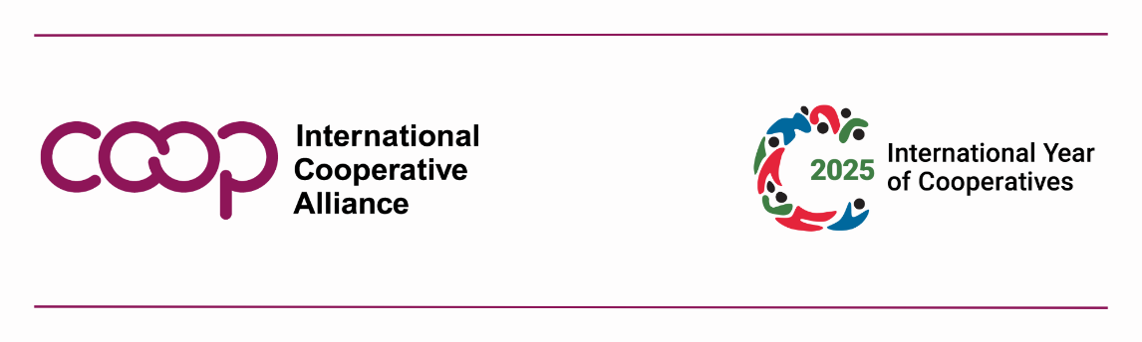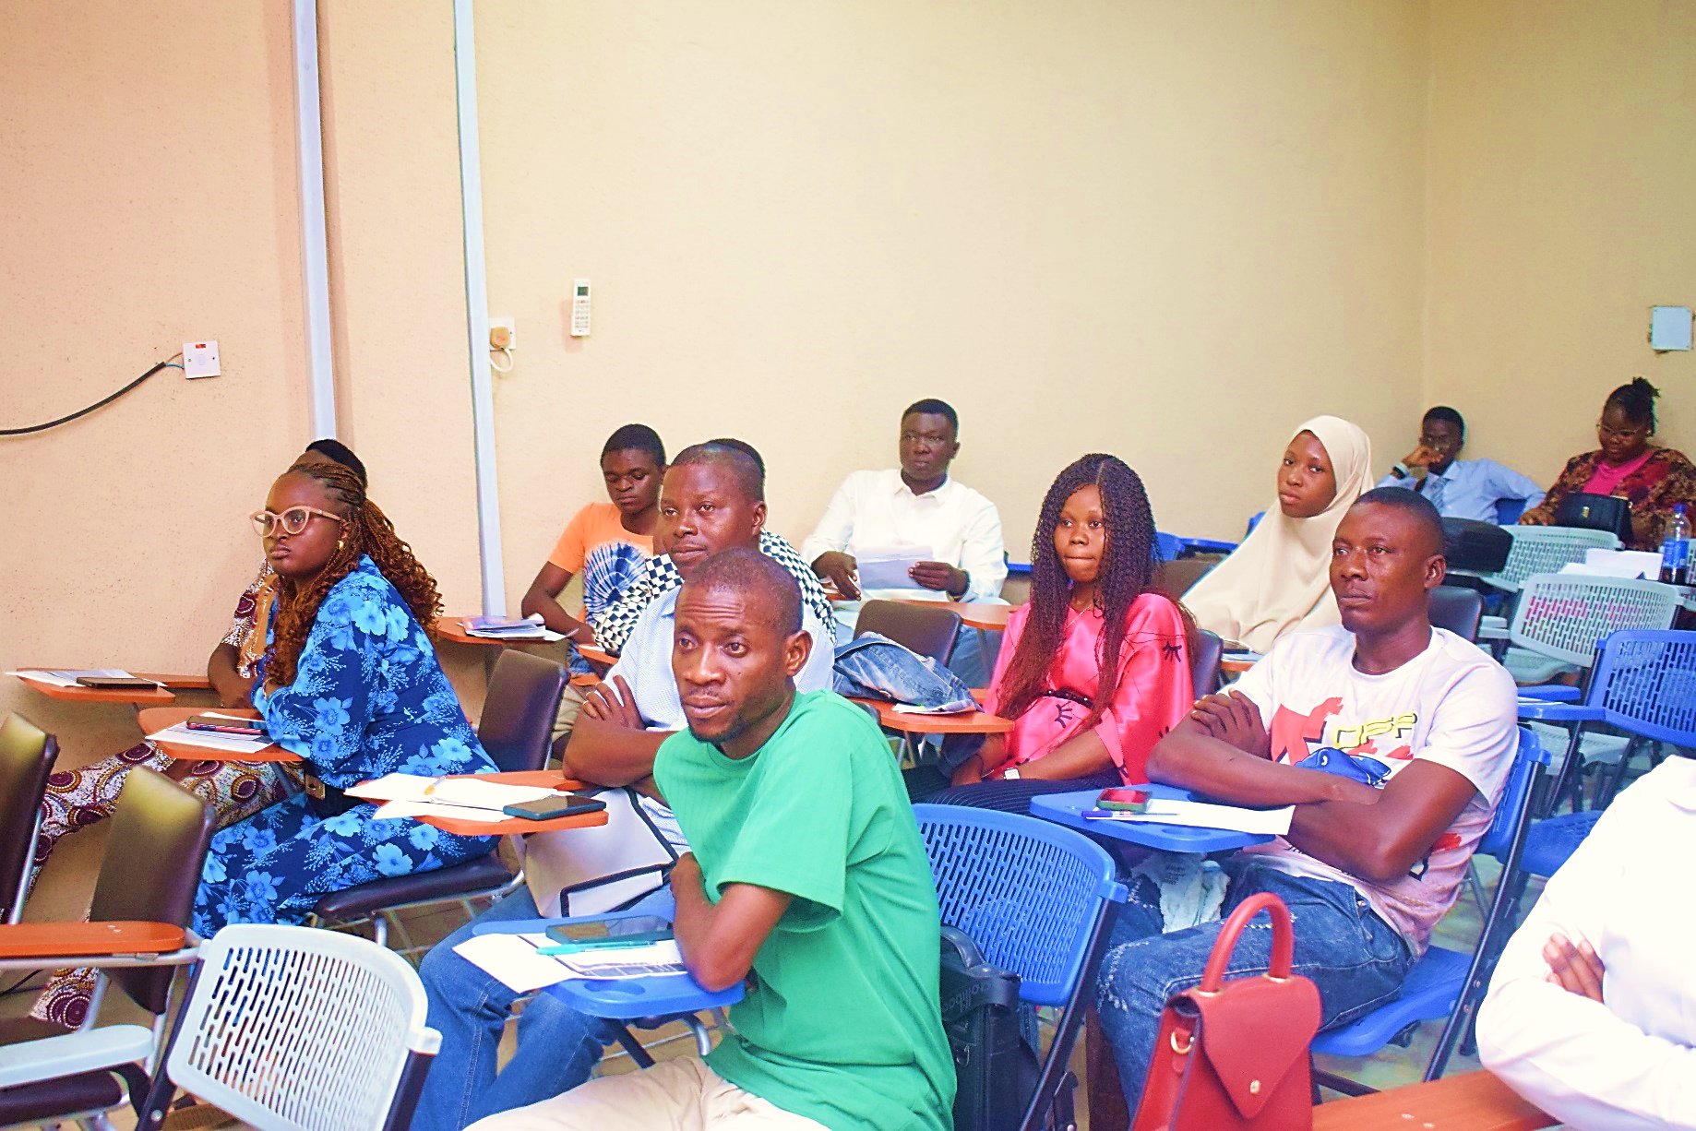

College were identified as critical priorities. These efforts aim to provide young people with the tools and platforms needed to drive the cooperative movement forward.

The Executive Secretary acknowledged the unique perspective and innovative energy that youth bring to cooperatives, noting their potential to navigate modern challenges and shape a sustainable future.

By involving young people in cooperative

governance and decision-making, the movement can remain adaptable and resilient in the face of economic and social changes.

As the session concluded, the meeting was both a call to action for youth and a reaffirmation of the cooperative model’s enduring values of equity, community development, and sustainability. By bringing young people into the fold, cooperatives can secure their impact and relevance for generations to come.

In an era where global economic systems often prioritize profit over people, cooperatives stand out as institutions committed to inclusivity, fairness, and sustainability. These member-driven organizations have emerged as a powerful alternative to traditional businesses, offering a democratic and community-focused approach to economic activity

Members called for mentorship programs led by experienced leaders to equip young cooperators with leadership and business skills.

Initiatives such as youth-focused events, cooperative walks, and workshops were proposed to raise awareness and attract more young people. Attendees also discussed policies to address age-related concerns and ensure inclusivity while exploring opportunities for collaboration with international organizations like the International Cooperative Alliance.

Looking ahead to 2025, which the United Nations has declared the "International Year of Cooperatives," the participants laid out plans to ensure continuous engagement and growth. Monthly meetings, comprehensive programs, and partnerships with institutions such as the Lagos State Cooperative

These efforts, she said, were essential as the cooperative movement continues to adapt to shifting economic realities.

Barr. Ajibola Akanji, a lecturer and cooperative law expert, offered an insightful keynote on the opportunities available within the cooperative sector. He urged young people to take ownership of their participation by understanding cooperative structures and laws, spanning primary, secondary, and tertiary Cooperative societies. He also stressed the importance of self-discovery and active engagement, encouraging youths to volunteer, conduct research, and develop personal connections within the movement. Respect for elders and leaders and the cooperative principles, he added, were foundation to success.

The meeting also addressed practical steps to strengthen youth participation.

Over a virtual meeting focused on the inclusion of young people in Nigeria’s cooperative movement, stakeholders underscored the necessity of integrating youth into the cooperative framework to ensure sustainability and continued relevance. The session reinforced the global recognition of cooperatives as powerful models of inclusion, equity, and sustainability, while laying out a vision for greater youth engagement in the sector.

The Executive Secretary Mrs Ebun Akin-Falaiye opened the session by emphasizing the critical role youth must play in the future of cooperatives, highlighting the need to dissolve generational divides and foster collaboration. She outlined key objectives, including the establishment of a youth network within cooperatives and the harmonization of ideas to build a vibrant and sustainable youth focused and youth-led association.

**Lagos Cooperative Movement Pays Tribute to Late Pa Akinwunmi, Pioneer of Modern Cooperatives in Lagos State**

The Lagos State Cooperative Federation (LASCOFED) hosted a commendation service to honor the life and legacy of the late Pa Titilope Kolawole Akinwunmi, a towering figure in Nigeria’s cooperative movement.

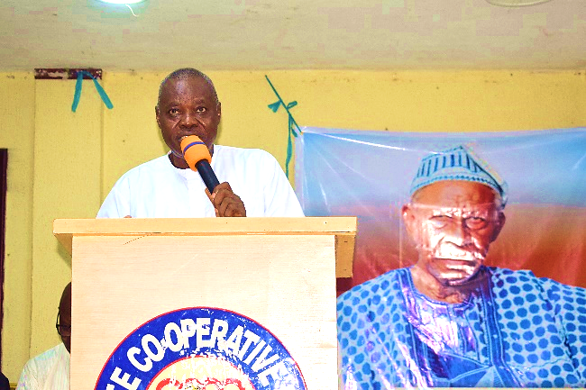

Similarly, **Alhaji Saheed Oki**, former LASCOFED President, highlighted the late leader’s **unwavering commitment to transparency,** boundless wisdom, and genuine kindness through which he taught the value of integrity. **Mrs. Ebun Akin-Falaiye**, spoke of Pa Akinwunmi’s **sacrifice, dedication, and generosity,** recalling how he **donated his personal shares** in Ogba Community Bank to ensure LASCOFED’s financial stability. Other tributes came from notable figures such as **Hon. Daniel Adejobi**, and LASCOFED’s Vice Presidents, who all spoke about the late leader’s role in fostering unity and financial transparency within the cooperative sector.

His legacy was further immortalized through his book, *Legacy to Cooperative Business Management*, a testament to his enduring influence on Nigeria’s cooperative movement.

As the cooperative movement bids farewell to this remarkable leader, his legacy of **honesty, service, and innovation** will continue to inspire future generations. **May his soul rest in eternal peace.**

of the Ojokoro Agricultural Multipurpose Cooperative Society to serving as President of LASCOFED, during which he established Lagos State Cooperative Finance and Investment Society Limited (LASCOFIS), making him the first President of LASCOFIS.

During his tenure he spearheaded groundbreaking initiatives, including:

* **Development of infrastructure.**
* **Creation of financial.**
* **Upholding financial integrity**, ensuring every kobo invested in cooperative projects was accounted for.

His visionary leadership positioned Lagos State cooperative movement as a model of success, inspiring generations of cooperative leaders across the state. In recognition of his exceptional contributions, the Cooperative Federation of Nigeria (CFN), the apex cooperative body in the country, honored him with a prestigious award in 2006. The following year, in 2007, he was installed as a Life Patron of the Lagos State Cooperative Federation (LASCOFED).

His legacy as a true icon of the cooperative movement was further cemented in 2014 when LASCOFED officially recognized him as a Cooperative Legend. The pinnacle of his recognition came in 2016 when he was inducted into the Lagos State Hall of Fame, an award jointly conferred by the Lagos State Ministry of Commerce, Industry, and Cooperatives and LASCOFED during the International Cooperative Day celebration.

The commendation service was an emotional yet inspiring event, with prominent figures showering glowing tributes on Pa Akinwunmi. **High Chief Oriyomi Ayeola**, Vice President of the International Cooperative Alliance Global, President ICA-Africa, CFN President and former LASCOFED President, described him as a **pillar of unity and progress**, emphasizing his significant role in shaping cooperative policies and institutions. LASCOFED President **Barr. Shobule** praised Pa Akinwunmi’s **financial acumen and leadership**, attributing much of LASCOFED’s present success to his visionary reforms.

The Lagos State Cooperative Federation (LASCOFED) recently held a commendation service to honor the life and legacy of **Pa Titilope Kolawole Akinwunmi**, an icon in Lagos State cooperative movement. The event, which took place at the LASCOFED Secretariat Multipurpose Hall, was attended by distinguished figures from the cooperative sector, family members, and other cooperative stakeholders, who gathered to pay last respect and celebrate his monumental contributions to cooperative development in Lagos State during his life time.

Born on April 19, 1938, in Abeokuta, Ogun State, Pa Akinwunmi built a legacy of dedication, innovation,

.

and integrity. His journey began at Baptist Boys High School, after which he trained as a Technical Officer at the Post and Telegraph (P&T) School in Lagos. He worked briefly as a bank clerk before embarking on further studies in Italy, specializing in plant pathology.

Upon returning to Nigeria from Italy where he studied Agriculture, he worked as an Agricultural Field Officer at the Nigerian Tobacco Company (NTC) before venturing into cooperative leadership, where he truly left his mark. He played a transformative role in Lagos State cooperative sector, rising through the ranks from a member

**LATE PA. T. K. AKINWUNMI**

**LASCOFED LOSES MEMBER OF BOARD OF DIRECTORS**

LASCOFED Shocked by a Painful Exit of a Member of the Board of Director (1972–2024)



Omoba Biodun Kumoye, a man of quiet strength and unwavering love, has passed away. Born on April 2, 1972, he dedicated his life to his family, passions, and community, leaving behind a legacy of kindness and knowledge.

His educational journey took him through Fagba Grammar College and Government Science and Technical College, Ilara, Ogun State, where he developed a deep curiosity and love for learning.

In 2003, he married Mrs. Kumoye Bolaji Florence, and together they built a loving home, raising four wonderful children: Kumoye Kofoworola, Ifebisola, Folayimi, and Gbadeyanka.

Omoba Biodun Kumoye found great joy in literature, both as an avid reader and a passionate writer. His love for words allowed him to express his thoughts and experiences, inspiring those around him.

At the time of his passing, he served as a member of LASCOFED Board of Director, representing Agege Multipurpose Cooperative Union as the President, and the President of Irede (Agege) CMS, contributing immensely to his community.

His legacy endures through his family and the countless lives he touched. May his soul rest in peace.



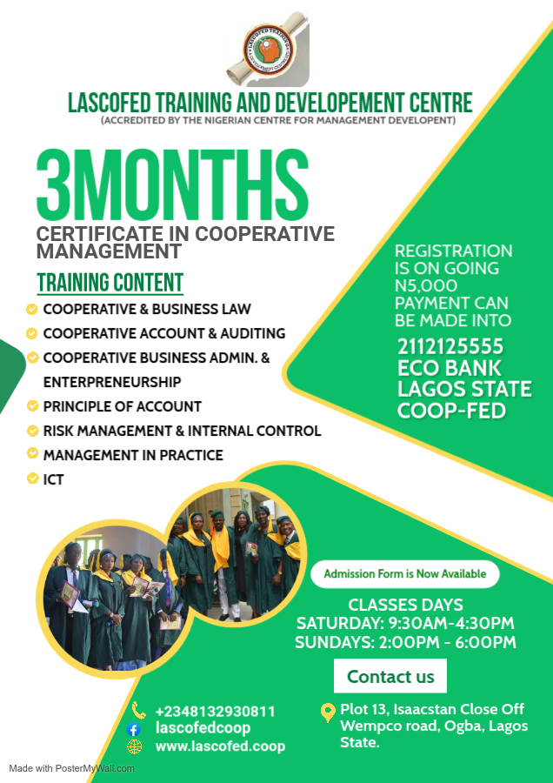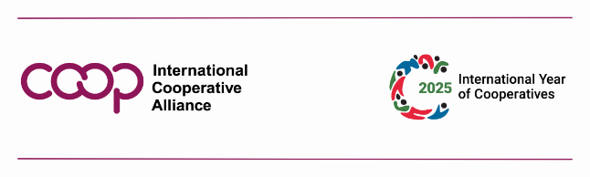

**UPCOMING EVENTS**

